Big Data Visualization Assignment – 2

Name - Gaurang Ashava

Reg No. - RA2111027010007

Section – AA1

Department – DSBS

Exercise 1 – Import Dataset 2018_WBIndicators.csv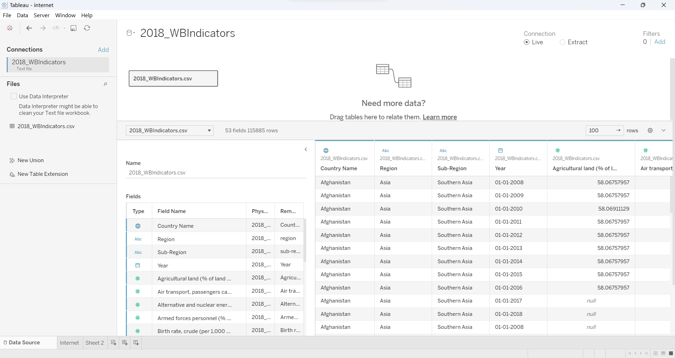

Exercise 2 – Create a Bar Chart

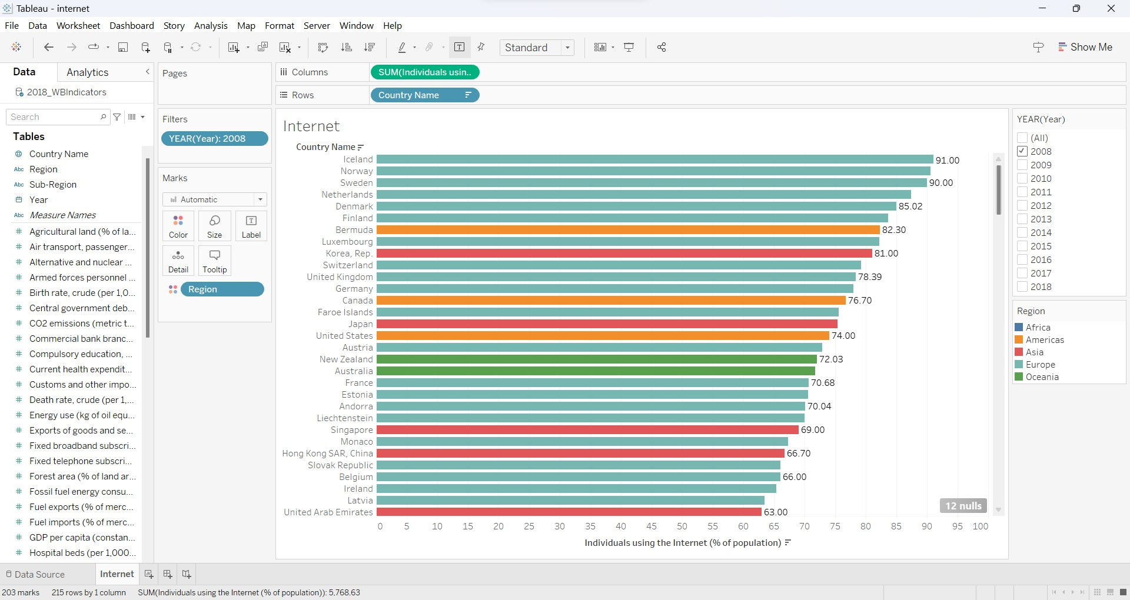

Exercise 3 – Bubble Chart

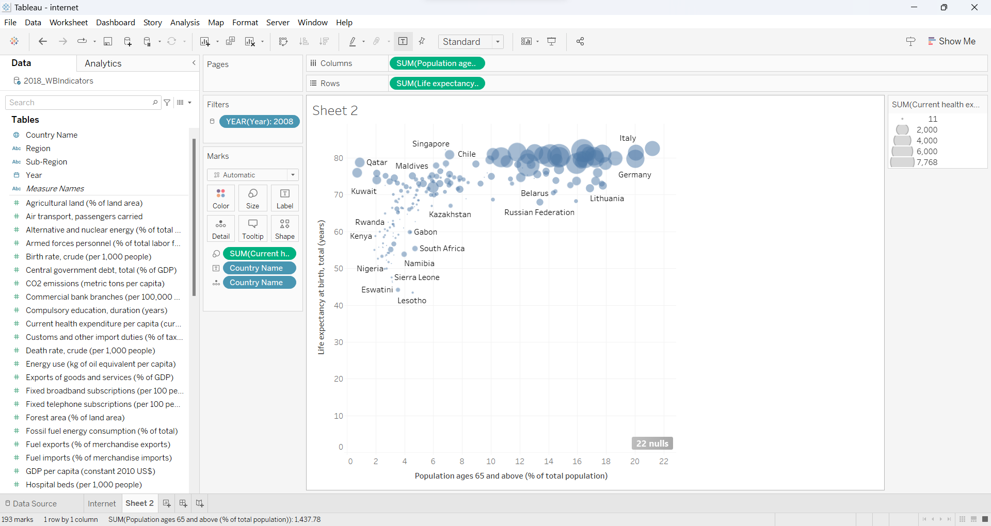

Exercise 4 – Map

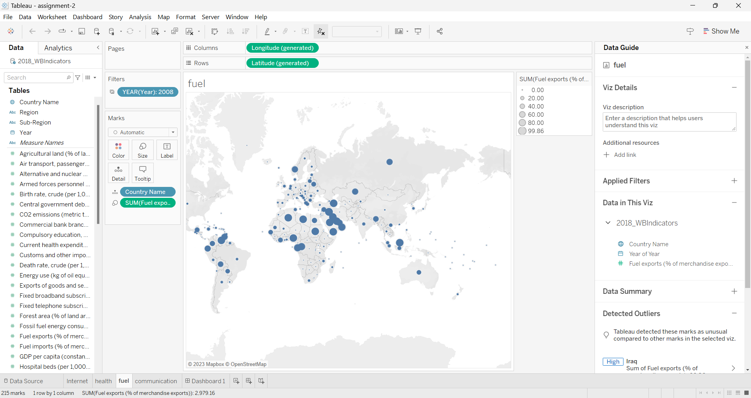

Exercise 5 - Two Charts in One Worksheet

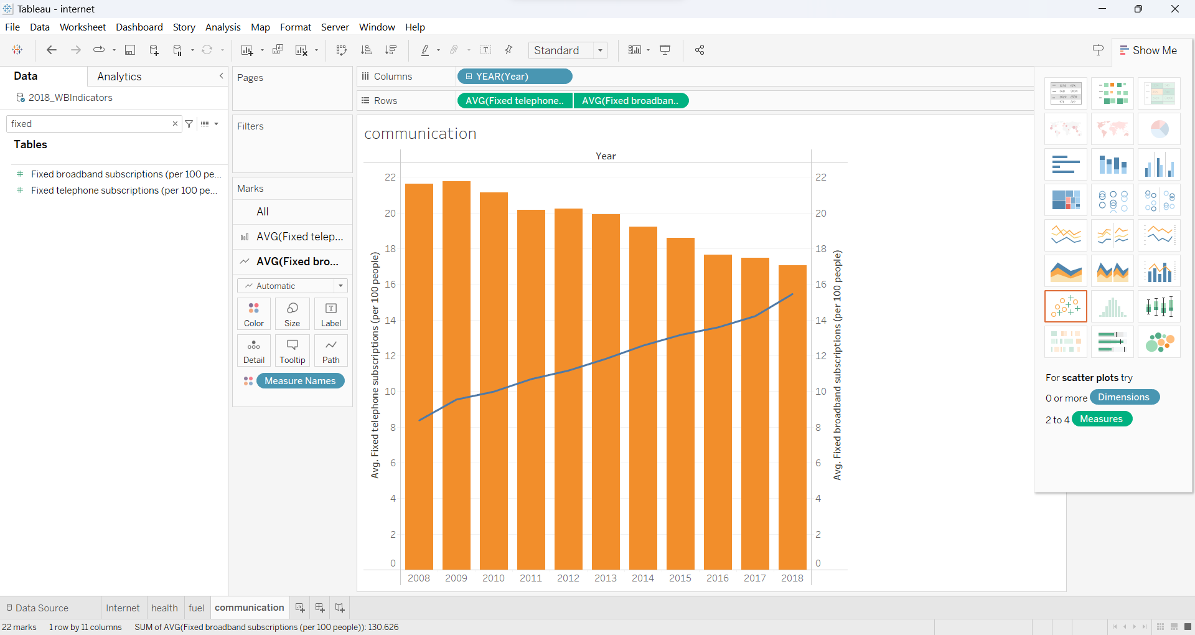

Exercise 6 – Dashboard

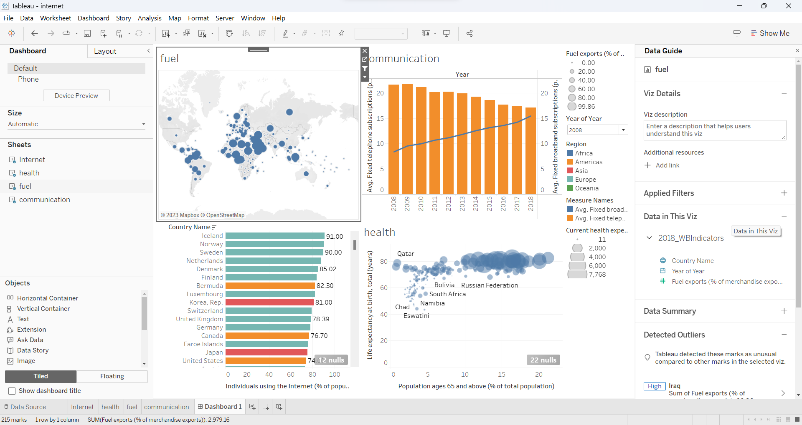

Exercise 7 – Saving File in Tableau

